**PROJECT REPORT**

*Spaceify*

*Akhil Kasturi, Ethan Long, Iman Ahmed, Jennifer Vaughn, Shayna Odle, Sharron Tum, Nathalia Valli*

Table of Contents

Project Proposal 2

Project Abstract 3

High Level Requirement 3

Conceptual Design 3

Proof of Concept 3

Background 3

Required Resources 4

Feature List 4

Constellation Playlists 4

Planet Display 4

Planet Animation 4

Connect with Others 5

Additional Features 5

Project Design 5

Vision 5

Personas 5

Class Diagram 7

Sequence Diagrams 8

Project Progress 10

Week 2 Progress 10

Week 3 Progress 11

Week 4 Progress 13

Risk Table 15

Test Reports 16

References 18

# Project Proposal

## Project Abstract

Spaceify is inspired by the many web applications like Reciptify, Instafest, Icebergify, etc. that reimagine new ways to visualize Spotify's listening data. Spaceify will display a user's top tracks in the past month, 6 months, and all-time in a new unique fashion. The user will be able to visually view their listening history in an aesthetic and fun manner with a planet theme and be able to share their Spotify space with their friends.

## High Level Requirement

The product allows a user to login to their Spotify account, and it will display a planet visual of their top artists.

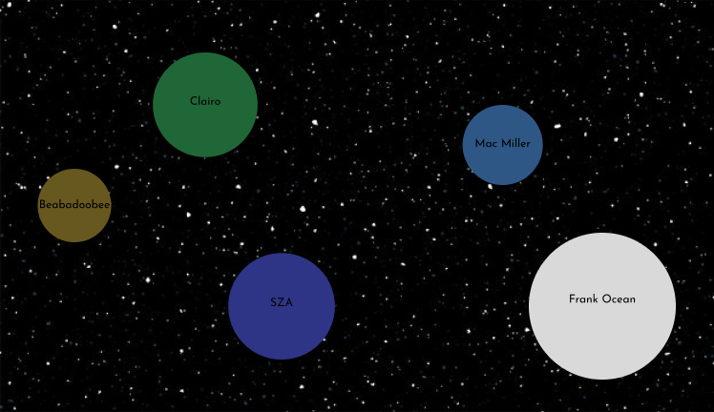

## Conceptual Design

We aim to create an interactive, aesthetic, space-themed scatter plot that visualizes a Spotify user’s top tracks over different durations. In terms of hardware, it will run on any machine with moderate specs. Linux systems would likely be ideal for development, though Windows or Mac can be used.

The application will most likely be running on Node.js, and we will use several programming languages throughout the process. This will include HTML & CSS, Javascript, and Python. Flask may be used for user authentication and React for building UI. We may also use D3.js or plotly for data visualization. We will need the Spotify Web API for fetching data.

## Proof of Concept

<https://github.com/cis3296f24/Spaceify>

## Background

In this project, I will retrieve data from Spotify on a user’s top tracks over different time periods. I will visualize the tracks using a planet-themed scatter plot, where each planet represents a song/artist. The size will depend on how many times the track has been played and I will use different colors and textures for different artists and genres. The distance of the planets could also represent something like how recent tracks are (x-axis could be time). I will attempt to add simple animations to the planets where they slowly rotate and also where if you hover over a planet, it will display additional information about the song. I will create a space background that will possibly be animated and attempt to add music.

Similar projects I am inspired by include:

Receiptify: <https://receiptify.herokuapp.com/>

<https://github.com/michellexliu/receiptify?tab=readme-ov-file>

Instafest: <https://www.instafest.app/>

Ngen: <https://ngenart.com/spotify>

## Required Resources

Will need to apply in the Spotify for Developers Dashboard in order to get own credentials.

I also will need to install node.js.

## Feature List

### Constellation Playlists

* **Feature Description**: Spaceify could create “constellations” by linking planets (songs) based on specific criteria. For instance, songs by the same artist or genre could be connected in star-like patterns, creating constellations within the space-themed scatter plot.
* **Dynamic Playlist Generation**: Each constellation could be a themed playlist, generated dynamically based on the criteria. Users could save and export these playlists to their Spotify account.
* **Visual Highlights**: When users hover over or select a constellation, it could illuminate, showing the connection between songs. Constellations could also be generated for:
  + **Moods**: Link songs that match a specific vibe (e.g., upbeat, chill).
  + **Genres**: Group songs by genre, showing users how often they listen to each genre.
  + **Time Periods**: Create constellations for each time period (last month, six months, all time), so users can see how their favorites have shifted.

This feature would add an extra layer of interactivity and customization, as users could discover new patterns in their music tastes while creating shareable playlists from Spaceify's unique visualizations.

### Planet Display

* **Feature Description**: The application will display the planets with different colors, textures, and sizes based on the users’ listening frequency of artists or songs.
* The more plays a song/artist has, the bigger the planet will be.
* Recently played tracks will be displayed closer to the x-axis.

### Planet Animation

* Be able to make the planets rotate.
* Hovering over a planet displays additional information about the song/artist.

### Connect with Others

* For this feature, users can connect with friends and family to see what they’ve been listening to. They can use this feature to discover new music, connect with friends, and make collab playlist stations.

### Additional Features

* Add music playing in the background of the website and specific music depending on a user’s top genre.

# Project Design

## Vision

Web application that combines data visualization with a space theme to represent Spotify listening habits. Users can log in with their Spotify accounts, and the app fetches data about their most-played tracks and artists. It visualizes this data as planets, scaled and positioned based on metrics like track popularity and duration. Unlike other Spotify summary services like Receiptify or Icebergify that have more complicated and detailed information displays, our product will display a user’s Spotify top tracks in a very simple manner with a planet-themed scatterplot and will allow users to click on the planets if they want more detailed information.

## Personas

**Emma, a highschooler**

Emma, age 16, is a high school student. She uses Spotify to listen to music, and she listens to a variety of genres and artists. At school, she meets a new friend. This new friend asked Emma if she could recommend her favorite songs since this friend has never used Spotify before and rarely listened to music. Emma wants to impress her new friend by providing song recommendations. However, due to her diverse taste in music, she cannot think of her favorite songs off the top of her head. Emma would be highly likely to use Spaceify in a situation like this because it will let her know what her most listened to songs are and how recently she listened to them. Additionally, the user-friendly graphic makes it easy for Emma and her new friend to interpret what Emma listened to the most based on how long those song planets are displayed.

**Isabel, a college student**

Isabel, age 21, is a college student in Philadelphia. She is a music tech major and has a band that plays at local house shows. Isabel meets new people and bands frequently and discovers new music every day. Recently, Isabel has been branching out and listening to different genres of music and artists. Since then, Isabel has been wanting to see her music tastes from the past few months and see a summary of her favorite artists and songs. Isabel would be interested in using Spaceify as it provides an overview of her favorite artists and songs over a period of time. The space-like graphics allow Isabel to easily view her favorite songs based on the graphics of the planets.

**Alex, Data analytics, recently graduated.**

Alex, age 24, is a recent college graduate working his first job in data analytics. Alex loves music and is a long-time Spotify user who often finds himself exploring new genres and artists based on his weekly recommendations. Besides just listening, Alex enjoys tracking his music data and discovering patterns in his listening habits. He’s interested in seeing how his top songs and artists vary over time, and he likes to compare his current music interests with those of previous months.

Alex would be excited to use Spaceify because of its unique data visualization format. The planet-based graphic representation allows him to easily observe his listening patterns at a glance, with planet sizes helping him quickly identify his most-played songs and artists. This visual summary would be appealing for Alex since it’s both fun and informative, aligning with his love for data and analytics in a highly aesthetic way. The ability to share this summary with friends and see trends over time also adds value for Alex, as it gives him insight into his evolving musical tastes and provides a way to share that journey with others.

**Walker, Graphic Designer**

Walker is 30-year-old Graphic Designer living in New York City who is always looking for new inspiration for his creative projects. Being visually driven and tech savvy, he is drawn towards modern concepts and the fast-paced advance of technology. Walker uses his unique art style to design logos and homepages for small companies and start-ups. In addition to his passion for design, Walker thoroughly enjoys listening to music, especially while he is creating. Spotify is his favorite music streaming service due to the ability to keep track of his favorite artists, playlists, and more.

Walker would enjoy Spaceify because of its creative and innovative way of visualizing his music history/data. Since Walker has an eye for design, the idea of planet sizes indicating how much he listens to each artist is a very compelling idea. Walker enjoys discussing music with his friends, so being able to compare listening history would work for a good conversation-starter. Going beyond a traditional list or graph, Spaceify allows Walker to creatively view and understand his listening patterns.

**Jim, a highschooler**

Jim is a 17 year old high school student. He lives in the suburbs. During school, he is very social and has a lot of friends. He likes to listen to music in between classes, and sometimes even in class. After school, he usually has practice for his football team. He is friends with the other kids on the football team who like similar music. Jim also uses social media a lot, mainly Instagram and Snapchat.

Because Jim enjoys listening to music and talking to others about it, he is always looking for ways to share this passion and find people with similar interests. He sometimes posts his yearly Spotify recap on his social media and enjoys the attention it receives. Jim is interested in using Spaceify to share his music interests on social media in a fun and satisfying way.

**John, uber driver**

John is a 32-year-old uber driver who lives in Miami. He has been looking for new ways to improve the ride experience for customers, so he purchased a Spotify account to play music in the car. John does not have a lot of musical knowledge, so he decided to use a recommended playlist that he found on the Spotify homepage. Over time, he realized that many people did not like this playlist and asked for specific songs or artists that they liked. John wanted to create a new playlist that matched the music taste of the riders better, but he did not know where to start. He is not great with technology and is having trouble thinking of songs to add. Spaceify would be a great product for John, as it will visually display what his customers’ favorite artists and songs are.

**David, tech manager**

David, a 45-year-old mid-level manager in a tech consulting firm in Washington, D.C., has spent over two decades building a successful career in the corporate world. With a diverse background working with various organizations, he understands the importance of fostering relationships and team dynamics. As Thanksgiving approaches, he hosts a Friendsgiving for his team, which includes several new members. Knowing that music is vital in creating a warm and inviting atmosphere, David turns to Spaceify, an innovative web application that visualizes Spotify listening data in a fun, planet-themed format. This allows him to explore his top tracks over the past month, six months, and all-time favorites in an aesthetic and engaging way.

Excited about Spaceify's collaborative features, David invites his coworkers to share their music preferences, enabling him to curate a playlist that caters to everyone's tastes. As he discovers new songs and blends them with familiar favorites, the playlist becomes a central part of the gathering, sparking conversations and creating connections among his guests. With each planet representing a song's popularity, David not only enhances the Friendsgiving experience but also reinforces his commitment to building a cohesive team culture. Ultimately, Spaceify transforms the evening into a memorable celebration, fostering laughter, and bonding.

## Class Diagram

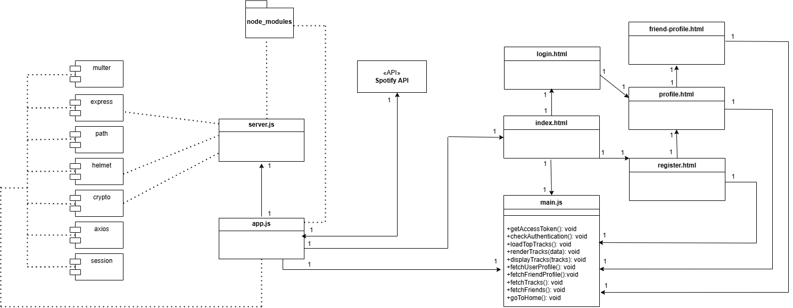

This UML class diagram represents the organizational structure of Spaceify. The packages that must be installed for Spaceify to run are shown on the left, represented as imported modules, which must be present for app.js and server.js to run properly. These files similarly depend on the node_modules package included at the top of the diagram. The middle of the diagram shows how data from the Spotify API is requested by app.js. The user is prompted to login to their Spotify account when requesting data from the Spotify API. Once a user’s login is authenticated, the Spotify data with the associated account can be accessed and displayed using main.js and index.html. From index.html, the user has the option to redirect to the login.html page to sign in or the register.html page to make a new Spaceify account. From those pages, the user is redirected to their profile at profile.html, which gives the user the option to be redirected to a friend’s profile at friend-profile.html. Friend-profile.html, profile.html, and register.html all use back-end functionalities that are established in main.js.

## Sequence Diagrams

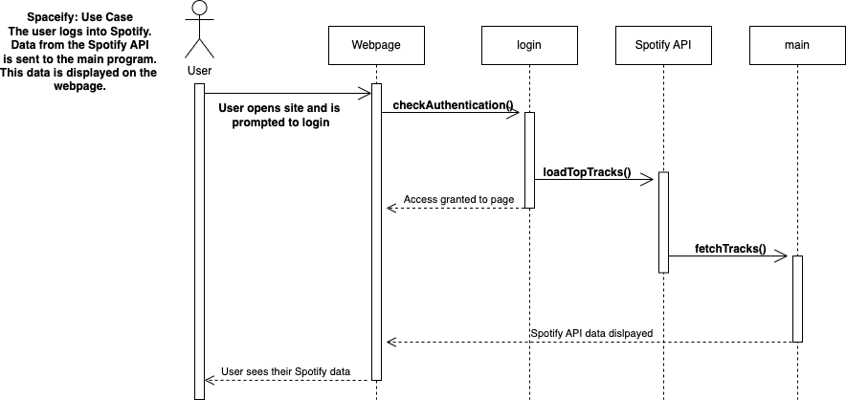This UML Sequence diagram shows a basic overview of how the user interacts with Spaceify to see their Spotify data. After opening the webpage, the user is prompted to login, which opens a login portal to Spotify. Once the user is authenticated, they will be granted access to the webpage, and their top tracks will begin to load. From here, with the provided Spotify credentials, the app will make a request to the Spotify API to load the users' top tracks. For this functionality to work properly the user must be signed up for the project’s Spotify Developer Dashboard or create their own developer project and add their developer credentials (outlined in readme). Once the Spotify API’s data is successfully loaded, the main program uses this data to create a ’solar system’ that displays information about top artists and tracks.

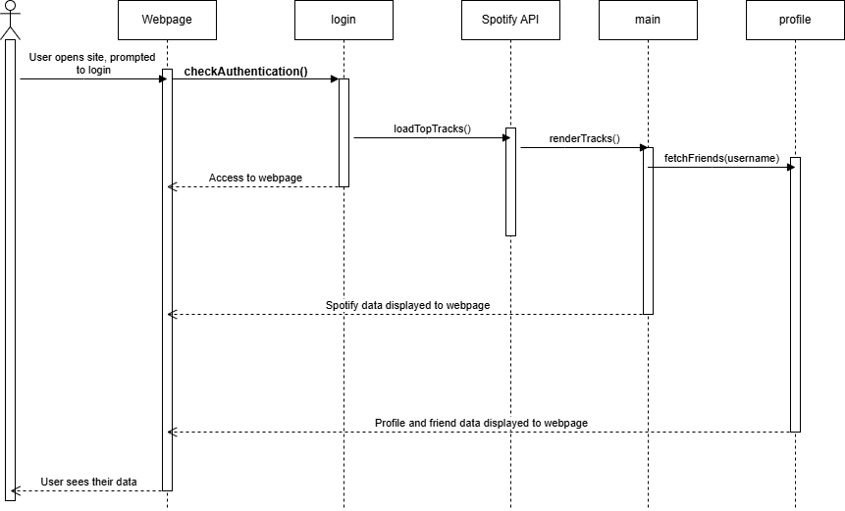This UML Sequence diagram shows the same login flow as the previous sequence diagram, with additional functionality for creating and using functionalities of a Spaceify account. This account, not to be confused with a Spotify account, adds new features to the website, such as logging in, managing friends, visit a friend's profile, and upload profile results. After the user logs into Spotify and their data is displayed on the profile, they can also create or log into a Spaceify account, set up using MongoDB. A user can add or remove a friend by typing their username when prompted, as well as upload a screenshot of their Spaceify results to be viewed on the profile page.

# Project Progress

## Week 2 Progress

**Sprint Goal:** The goal of Sprint 2 is to add the Spotify API to allow users to login and use their personal listening data, add a few backlog features, and create the UML class diagram.

**Backlog Features**

* Add Spotify API
* Constellation Playlist - Hovering over constellation creates illumination.
* Planet Display - Display planets based on listening frequency (size) and artist (color and texture).
* Planet Animation - Rotate planets.
* Additional features - Adding music to background.

|  |  |  |  |  |
| --- | --- | --- | --- | --- |
| **Tasks in Sprint** | **Size** | **Numerical size** | **Task Status at end of Sprint** | **Assigned To** |
| Add Spotify API | L | 8 | Completed | Nathalia |
| Constellation illumination | M | 5 | In-progress | Jennifer |
| Planet hover animation | S | 3 | Completed | Shayna |
| Planet display based on listening frequency (size) and artist | M | 5 | In-progress | Ethan |
| Rotate planets | L | 8 | In-progress | Iman |
| Add background music | M | 5 | In-progress | Sharron |
| UML Class Diagram | M | 5 | Completed | Akhil |
| Update project report – High Level Requirements and Project Progress | S | 3 | Completed | Jennifer |
| New release | S | 3 | Completed | Sharron |
| Fix Planet Display and Background | M | 5 | In-progress | Nathalia |

**Estimated velocity** (At beginning of sprint)**: 47**

**Calculated velocity** (At end of sprint)**: 22**

## Week 3 Progress

**Sprint Goal:** The goal of Sprint 3 is to finish a few backlog features that we started in Sprint 2 and to create the UML sequence diagram.

**Backlog Features**

* Constellation Playlist - Hovering over constellation creates illumination.
* Planet Display - Display planets based on listening frequency (size) and artist (color and texture).
* Planet Display- Make planets fit the screen better
* Planet Animation - Rotate planets.
* Additional features - Adding music to background.
* Planet Animation - Hovering over planet displays additional information about artist.

|  |  |  |  |  |
| --- | --- | --- | --- | --- |
| **Tasks in Sprint** | **Size** | **Numerical size** | **Task Status at end of Sprint** | **Assigned To** |
| UML Sequence Diagram | M | 5 | Completed | Akhil |
| Hovering over planet displays additional information about artist | M | 5 | Completed | Shayna |
| Hovering over constellation creates illumination | L | 8 | In progress | Jennifer |
| Display planets based on listening frequency (size) and artist (color and texture) | M | 5 | In progress | Ethan |
| Change planet position formula | S | 3 | Completed | Akhil |
| Rotate planets | L | 8 | In Progress | Iman |
| Adding music to background | M | 5 | Completed | Sharron |
| Fix Planet Display and Background | M | 5 | Completed | Nathalia |
| New Release | XS | 1 | Completed | Sharron |
| Risk Analysis | S | 3 | Completed | Sharron |

**Estimated velocity** (At beginning of sprint)**: 48**

**Calculated velocity** (At end of sprint)**: 32**

## Week 4 Progress

**Sprint Goal:** The goal of Sprint 4 is to complete some backlog features from previous sprints, add new backlog features, fix the planet display, update the project report and ReadMe as needed, add a testing report section to this report, and create a new release.

**Backlog Features**

* Constellation Playlist - Hovering over constellation creates illumination.
* Planet Display - Display planets based on listening frequency (size) and artist (color and texture).
* Planet Animation - Rotate planets.
* Additional features - Specific music playing in background depending on genre.
* Connect with Others - Be able to connect with other users to see what they have been listening to.
* Planet Animation - Hovering over planet displays additional information about artist.

|  |  |  |  |  |
| --- | --- | --- | --- | --- |
| **Tasks in Sprint** | **Size** | **Numerical size** | **Task Status at end of Sprint** | **Assigned To** |
| Hovering over constellation creates illumination. | M | 5 | In Progress | Jennifer |
| Rotate planets | M | 5 | In Progress | Iman |
| Display planets based on listening frequency (size) and artist (color and texture) | M | 5 | Completed | Ethan |
| New release | XS | 1 | Completed | Sharron |
| Specific music playing in background depending on genre. | M | 5 | In Progress | Sharron |
| Be able to connect with other users to see what they have been listening to. | M | 5 | In Progress | Jennifer |
| Update project report as needed | XS | 1 | Completed | Jennifer |
| Fix planet display | S | 3 | Completed | Akhil |
| Add testing report to this report (Output of automated tests & coverage report) | M | 5 | In Progress | Nathalia |
| Update release notes and Readme | XS | 1 | Completed | Nathalia |
| Hovering over planet fetches additional information from Spotify API about artist. | L | 8 | Completed | Shayna |
| Click on artist planet to create a new window with tracklist. | M | 5 | Completed | Shayna |

**Estimated velocity** (At beginning of sprint)**: 44**

**Calculated velocity** (At end of sprint)**: 24**

# Risk Table

**Categories:**  
PS - Product Size  
BI - Business Impact  
CC - Customer Characteristics  
PD - Process Definition  
DE - Development Environment  
TR - Technology to be built  
ST – Staff  
**Impact Values:**  
1 - Catastrophic  
2 - Critical  
3 - Marginal  
4 - Negligible

|  |  |  |  |  |
| --- | --- | --- | --- | --- |
| **Risk** | **Category** | **Probability** | **Impact** | **RMMM** |
| **Technology and Access Issues** | **DE** | **30%** | **3** | **Mitigation**  Ensure that Spotify API works for the users  **Monitoring**  Check the accuracy of the top artists and tracks and check if Spotify users are able to use their accounts.  **Management**  Have alternative solution in case Spotify API doesn’t work |
| **Not Completing Deliverables** | **ST** | **40%** | **2** | **Mitigation**  Start working on deliverables ahead of time  **Monitoring**  Update project board and communicating when there are issues  **Management**  Acknowledge any time conflicts or issues ahead of time |
| **Scheduling and Time Management** | **ST** | **40%** | **3** | **Mitigation**  Work on feature ahead of time  **Monitoring**  Track progress and project board to monitor upcoming tasks  **Management**  Acknowledge schedule and time conflicts ahead of time |

# Test Reports

Our tests were made after the program was running. Some of our functions were very difficult to test and the code needed to be refactored but because of the time crunch will leave as it to something to be improved later on.

App.js

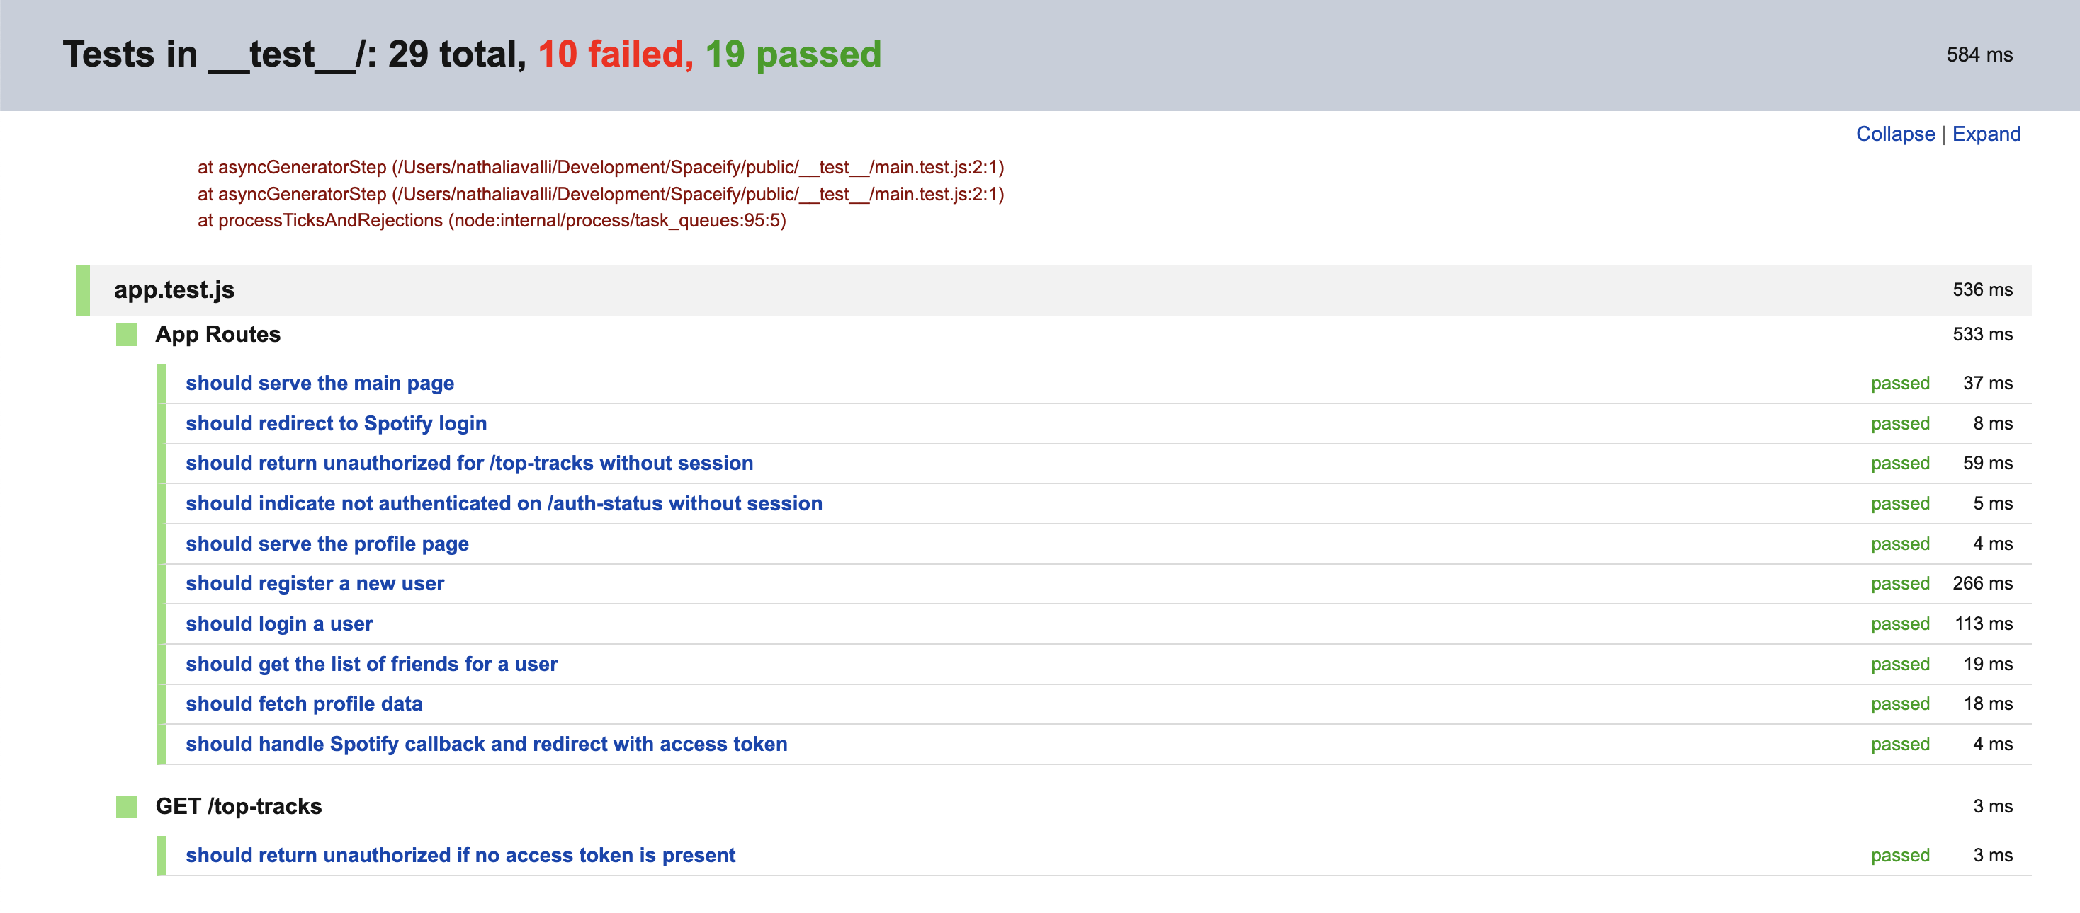

Main.js

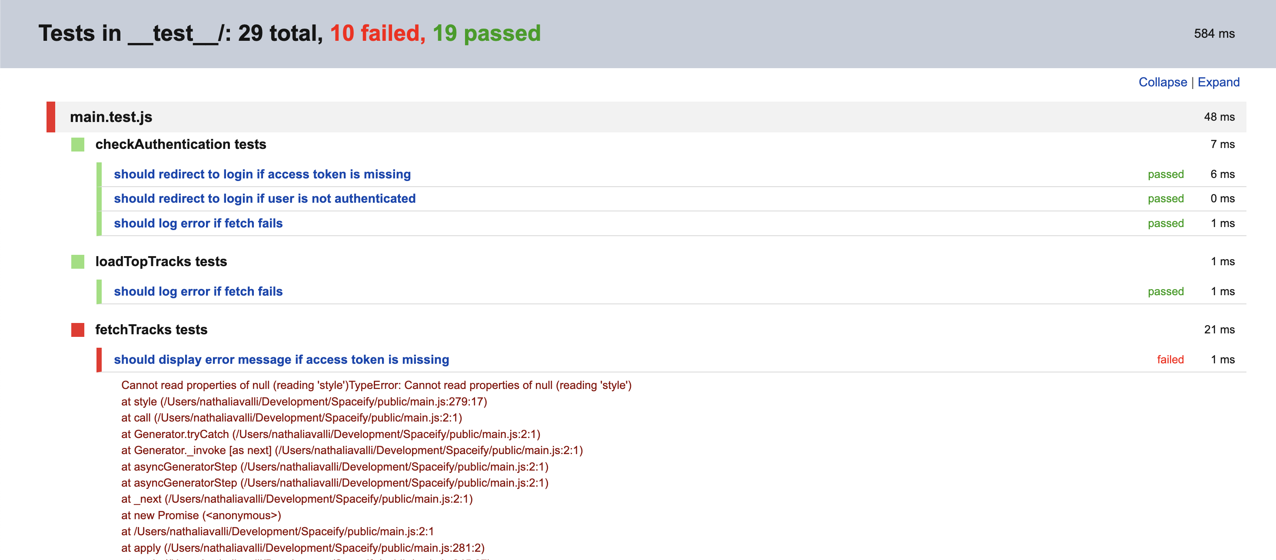

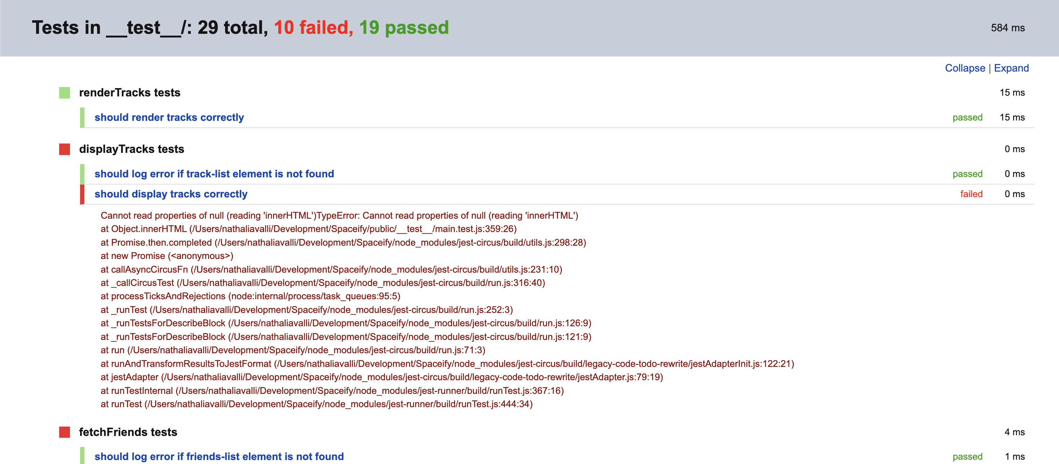

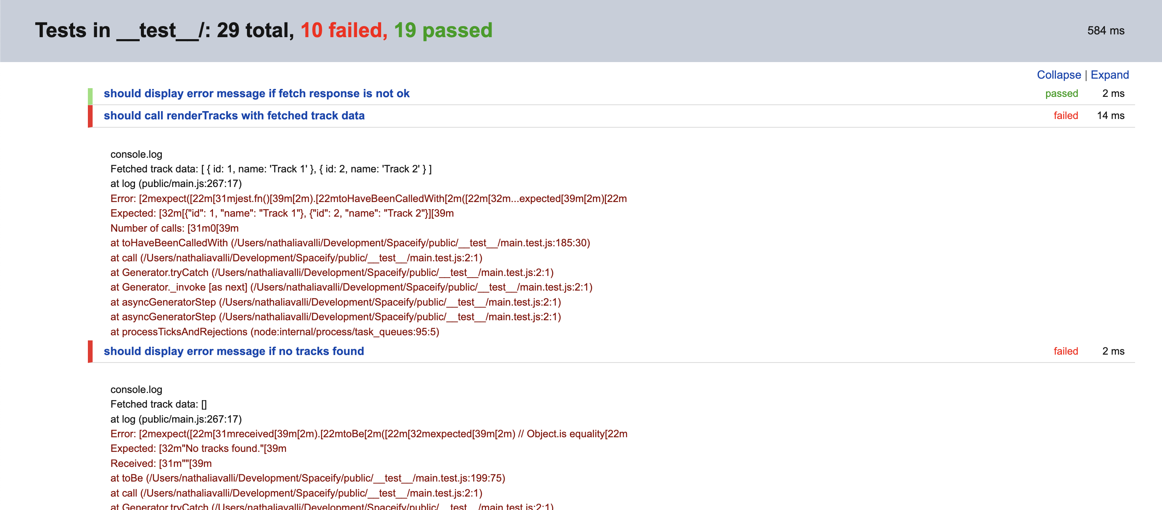

**Coverage:**

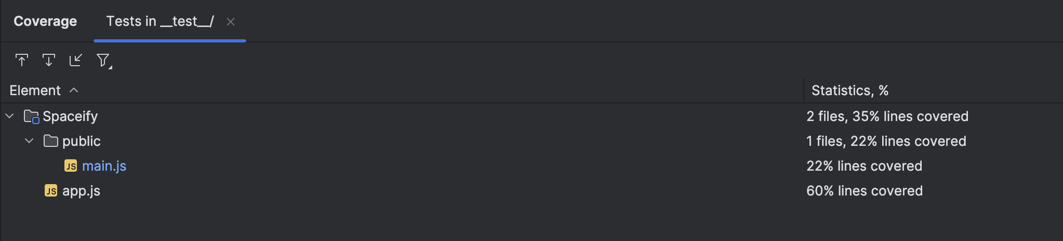

# References

Spotify API documentation:

<https://developer.spotify.com/documentation/web-api/tutorials/getting-started>

Javascript documentation:

<https://node-oracledb.readthedocs.io/en/latest/index.html>

Jest documentation:

<https://archive.jestjs.io/docs/en/22.x/getting-started.html>

MongoDB documentation:

<https://www.mongodb.com/docs/>